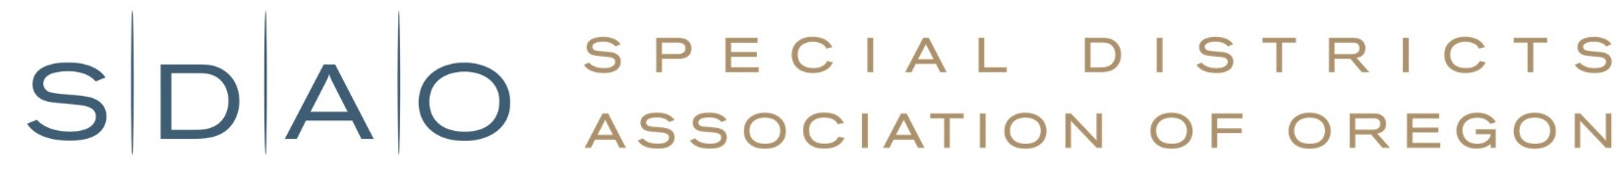

Oregon State Interoperability Executive Council

# Nomination Form

Please complete and submit this form by **Friday, May 10th, 2024**

|  |
| --- |
| **CONTACT INFORMATION:** |

|  |  |  |  |
| --- | --- | --- | --- |
| Full Name: |  | Mailing Address: |  |
| Title: |  | Email Address |  |
| District Name: |  | Phone Number: |  |

|  |
| --- |
| **PLEASE ANSWER THE FOLLOWING QUESTIONS:** |

1. Describe your understanding of communication interoperability among state, local, tribal and federal public safety agencies:

2. Describe challenges you are aware of for developing and implementing a statewide communication interoperability system:

3. What specific expertise do you have in the area of emergency communications and communications interoperability?

4. Describe how your background and expertise will add value to the Council:

5. Is your district supportive of the time commitment to serve on the Council?

|  |
| --- |
| **TO SUBMIT YOUR FORM:** |

Please send completed form to:

SDAO | PO Box 12613 | Salem, OR 97309-0613

Or by email to:

[memberservices@sdao.com](mailto:memberservices@sdao.com)